|  |  |
| --- | --- |
| **WC Logo.emf** | **Staff Report to the Weber County Commission**  *Weber County Planning Division* |
|  | |

****Synopsis****

****Application Information****

**Application Request:** A public hearing to consider and take action on a request to vacate 2 feet of a 10 foot public utility easement, located along the west boundary of lot 2, Fremont Subdivision.

**Agenda Date: Tuesday, January 11, 2022**

**Applicant:** Douglas Evans, Owner

**File Number:** EV 2021-08

****Property Information****

**Approximate Address:** 333 S 5900 W, Ogden, UT, 84404

**Project Area:** 0.92 acres

**Zoning:** A-2 Zone

**Existing Land Use:** Residential

**Proposed Land Use:** Residential

**Parcel ID:** 10-116-0002

**Township, Range, Section:** T6N, R3W, Section 19 Qtr Section 13 NE

****Adjacent Land Use****

**North:** Residential **South:** Jennifer Drive

**East:** Residential **West:** Residential

****Staff Information****

**Report Presenter: Tammy Aydelotte**

taydelotte@webercountyutah.gov

**801-399-8794**

**Report Reviewer:** SB

Background and Summary

The applicant has requested to vacate 2 feet of a 10 foot public utility easement located along the west boundary, leaving the entire 10 foot public utility easement along the southern boundary intact, of lot 2, Fremont Subdivision. The applicant is requesting the vacation to allow for an accessory structure 8’ from the rear (west) lot boundary.

Summary of County Commission Considerations

The County Commission will need to determine if there will be any detrimental impacts caused by vacating the proposed portion of an existing public utility easement. Utah Code §17-27a-609.5 states that *“The legislative body may adopt an ordinance granting a petition to vacate some or all of a public street, right-of-way, or easement if the legislative body finds that:*

*(a) good cause exists for the vacation; and*

*(b) the public interest or any person will not be materially injured by the proposed vacation.*

Conformance to the General Plan

Vacating a portion of the identified easement is not anticipated to have a negative effect the West Central Weber General Plan.

Staff Recommendation

Staff recommends approval of the request to vacate 2 feet of the existing 10 foot public utility easement along the western lot boundary, leaving the entire 10’ public utility along the southern lot boundary. This recommendation for approval is subject to all review agency requirements.

The recommendation is based on the following findings:

1. Vacating the proposed public utility easement will not have a negative effect on the Ogden Valley General Plan.
2. Based on the proposed subdivision amendment, good cause exists to vacate the easement.
3. The public interest or any person will not be materially injured by the proposed vacation.

Exhibits

1. Easement Vacation Application with Narrative
2. Proposed Vacation Ordinance

Location Map

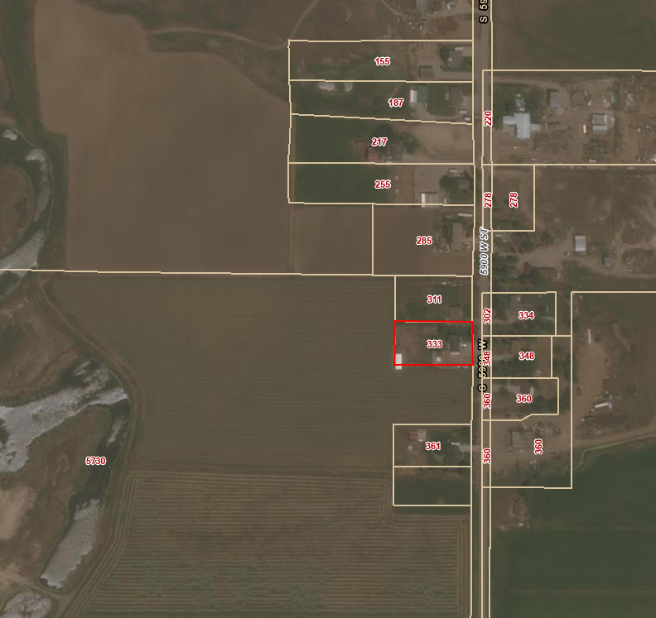

Exhibit A – Easement Vacation Application with Narrative

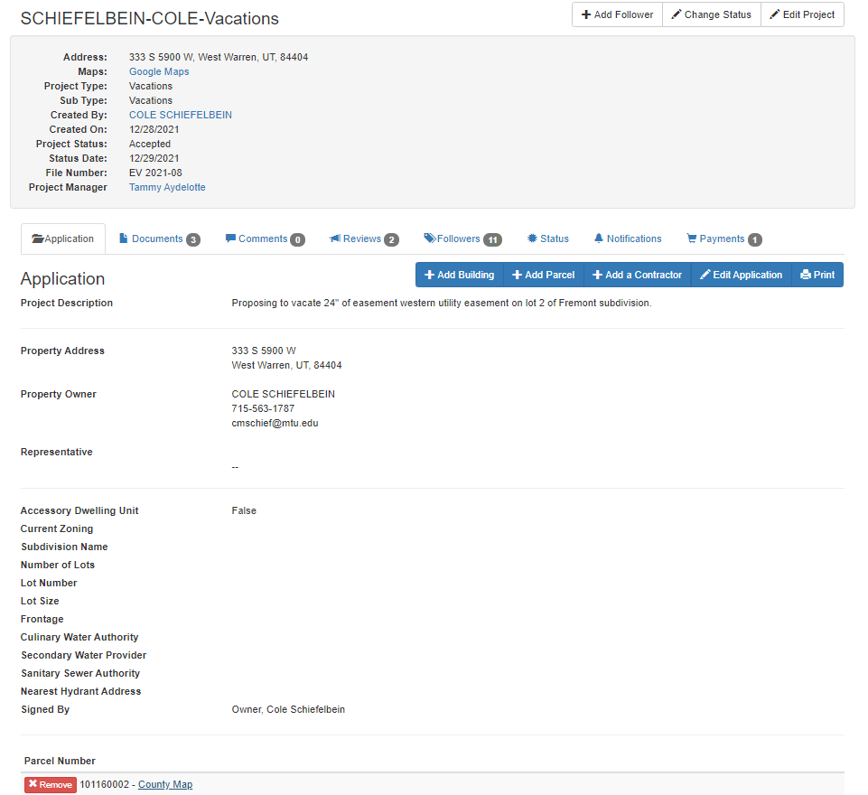

Exhibit B – Proposed Vacation Ordinance